

FRONT END – PART 1
STYLING WITH CSS

Code : Margin
As you know, an element's margin controls the amount of space between an element’s border and surrounding elements.
If you set an element’s margin to a negative value, the element will grow larger.
So your task is:
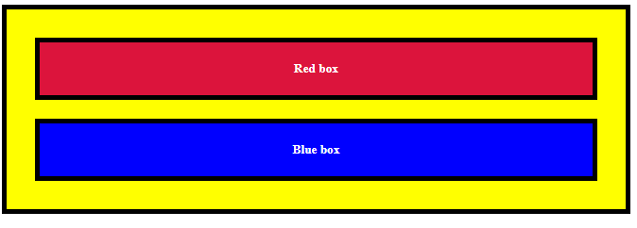
1.To set the margin to a negative value for the red box.
2.Change the margin of the blue box, so it fills the entire horizontal width of the yellow box around it.

Expected Output:


**********

